**Scenario Editor**

**User Manual**

Table of Contents

General Information: 2

User Interface 2

Ego Vehicle (AI) 3

Placement 3

Ego Settings 3

Simulation Entity (Adversary) 4

Placement 4

Entity Settings 4

Route 5

Waypoint Settings 5

Start Route Property 5

Automatic Lane Changes 6

World Settings 6

Save and Export a Scenario 6

Example 7

# General Information

This application is a Scenario Editor to create Scenarios which can be run in the Simulation software Carla. In this Scenario Editor you can place cars, motorcycles, bicycles, and pedestrians.   
The first placed entity is the Ego Vehicle which drives with an Artificial Intelligence. The Ego Vehicle is always visualized in the color white by default. The Ego Vehicle will drive to a specified destination.  
All other entities are Simulation Entities or Adversaries. They are visualized in any random color except white. For each Simulation Entity you can define a path with custom-defined actions along the path.

# User Interface

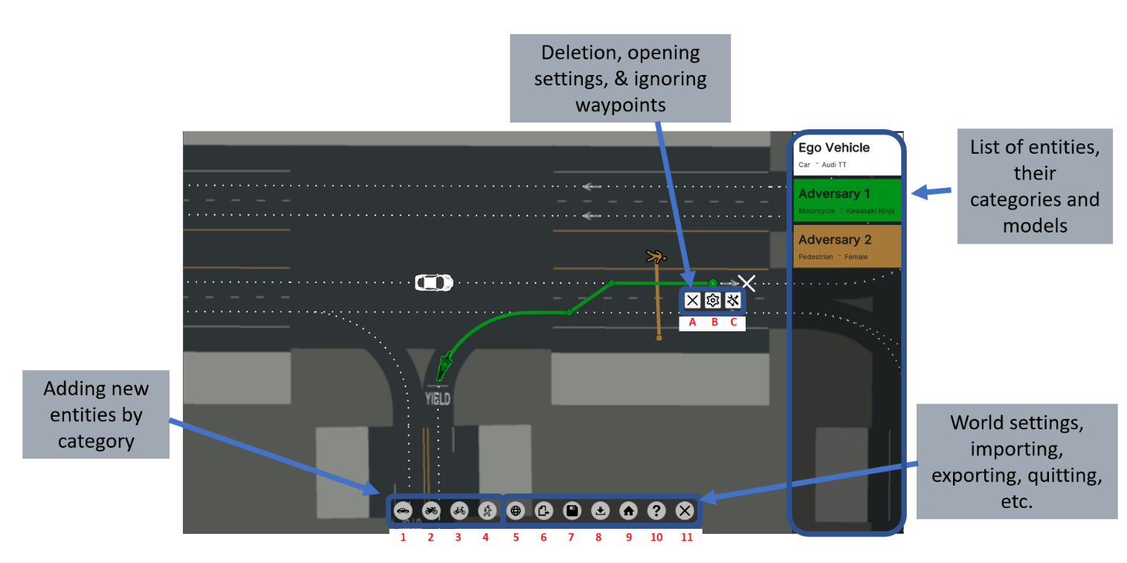

1. Place a **car**.
2. Place a **motorcycle**.
3. Place a **bicycle**.
4. Place a **pedestrian**.
5. Adjust **weather** settings.
6. **Export** scenario as OpenScenario .xosc format. This format can be run in the Simulation software Carla.
7. **Save** this scenario to edit it later again.
8. **Load** a saved scenario.
9. Switch the **map**. Unsaved changes will be lost.
10. Open the documentation for **help**.
11. **Close** the application. Unsaved changes will be lost.
12. **Delete** the selected Entity.
13. Open Entity **Settings** to change properties like initial speed, model, color, ...
14. Disable/ Enable ***Ignoring Waypoints* option**. By default, cars and motorcycles use waypoints and bicycles and pedestrians ignore waypoints. If enabled, you can freely place and move the entity across the map and not just on waypoints (white dots on the road).

# Ego Vehicle (AI)

The first placed vehicle is the Ego Vehicle (AI). This vehicle is marked in a **white** color.

## Placement

1. Click one of the first 3 buttons at the bottom of the screen. 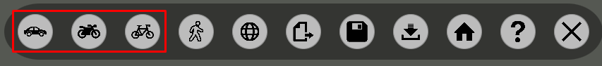
2. Place it on a Waypoint (white dot) on the road.
3. Place the destination (white cross) somewhere on the road on a Waypoint (white dot). Ein Bild, das Nachthimmel enthält.

   Automatisch generierte Beschreibung

## Ego Settings

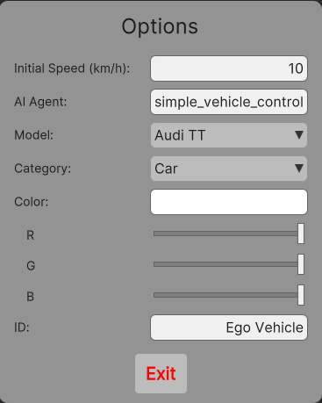

Initial Speed Defines, how fast the Ego Vehicle drives in the beginning. It directly has this speed.

AI Agent Write the name of your Artificial Intelligence. By default, a simple AI of Carla is used.

Model Changes the car model.

Category Change the category to Car, Motorcycle or Bike. Be aware, that pedestrian is not support by the Ego Vehicle.

ID Change the name of the ego vehicle. It must be unique.

# Simulation Entity (Adversary)

## Placement

Click one of the first 4 buttons at the bottom of the screen and place the entity on a road. All 4 categories are supported.

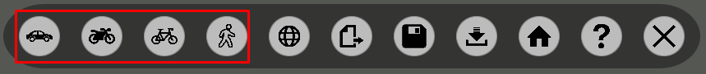

## Entity Settings

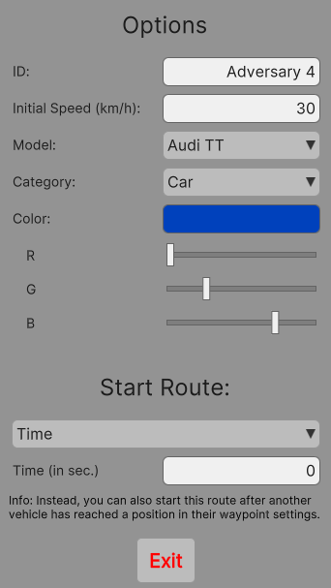  
  
ID Change the name of the Simulation entity. It must be unique.

Initial Speed Defines, to which speed the Simulation Entity accelerates in the beginning. The speed can be changed anytime along the path on the Waypoint Settings.

Model Changes the car model.

Category Change the category to Car, Motorcycle, Bike, or Pedestrian.

Color Adjust the sliders to change the color.

## Route

Select the Simulation Entity and click somewhere on the map to create the entity’s path. While hovering over the map you can see the calculated route. You can adjust a route by adding, moving, and deleting waypoints. Click on a waypoint and drag it, to move it to a new location. Click somewhere on the route or on the map to add a new waypoint. Press the button *Delete* to remove it.

### Waypoint Settings

Each waypoint on a route has its individual Waypoint Settings. Here, you can define up to three actions. First, a Speed Action. Second, a Stop Action. Third, a manual Lane Change Action.

1. Ein Bild, das Text enthält.

   Automatisch generierte BeschreibungSpeed Action
   1. When the Simulation Entity reaches this waypoint’s location, it will adjust to the new speed.
2. Stop Action
   1. When the Simulation Entity reaches this waypoint’s location, it will break to the speed 0 and stand still for the specified amount of time. After that, it will accelerate to the previous speed. If a Speed Action is defined in this Waypoint Settings, the Adversary will instead accelerate to the speed of the Speed Action.
3. Manual Lane Change Action
   1. Only experienced users should use the Manual Lane Change Action. This action is useful in case very precise lane changes are needed. Otherwise, lane changes can easily be created by adding or moving waypoints on the path.

### Start Route Property

Ein Bild, das Text enthält.
Sometimes it can be useful, if an Adversary only starts driving along its route after other conditions are fulfilled. For example, a vehicle should only move after a pedestrian crossed the street or generally, another entity reaches a specific location.   
  
There are 3 options to start the route of a Simulation Entity:

1. Time
   1. Default option. Start, after X seconds passed. Time is adjustable.
   2. This option can be configured in the Adversary Settings.
2. Distance to the Ego Vehicle
   1. Start, if the Ego Vehicle is less than X meters away. If this condition is never true, this Adversary will never start.
   2. This option can be configured in the Adversary Settings.
3. Another Adversary Position
   1. Start, if another Simulation Entity reached a specific location.
   2. This option can be configured in the Waypoint Settings of other Simulation Entities. If selected, this option is shown in the Adversary Settings and can also be deleted there.

### Automatic Lane Changes

  
If you have issues with lane changes: Make sure to set a waypoint on the correct lane. The automatic Lange Changes on the path don’t happen on the same Road Section as the Spawn Point of the Vehicle.  
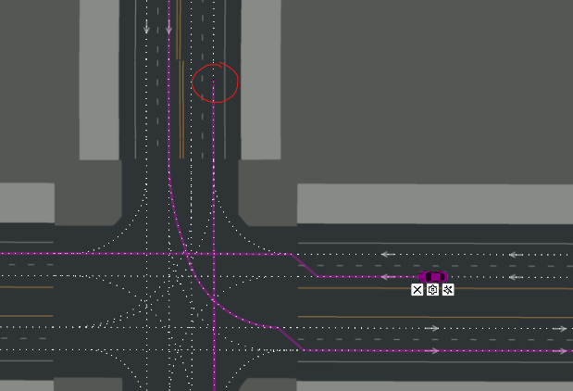 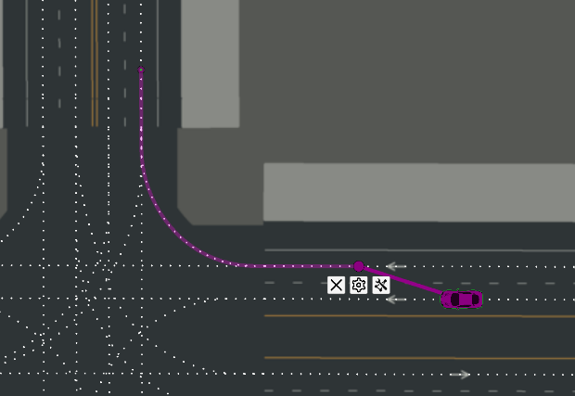

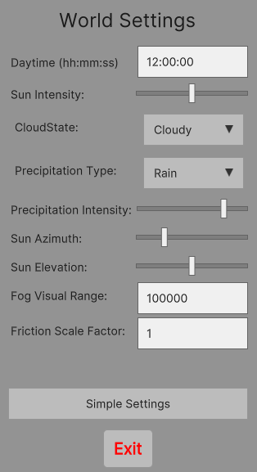World Settings  
  
You can open the World Settings by clicking the fifth icon on the menu bar.   
World Settings allow you to change the weather in the scenario. By default, it is not raining (*Dry*). When changing the Precipitation Type to *Rain*, it will rain when running the scenario in the simulation software Carla. Illogical weather conditions are also possible. For example, it can rain but no cloud is on the sky (*Free*). Advanced users can adjust more weather settings by clicking the button *Advanced Settings*.  
  
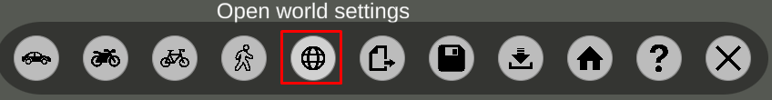

# Save and Export a Scenario

It is a good practice to save the scenario while you are creating it to prevent unsaved losses. You can save the current state of the scenario by clicking the 7. icon on the menu bar. A scenario can be loaded by clicking the 8. icon on the menu bar. This will override your current scenario and any unsaved changes will be lost! You can only load saved scenarios in the .sced format. Exported scenarios in the .xosc format cannot be used to load a scenario!  
At the end, you should export the scenario by clicking the 6. icon on the menu bar. It converts the created scenario to an Carla compatible .xosc format.

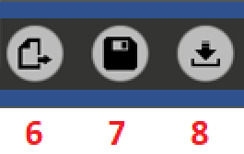

# Example

We want to create a scenario with the Ego Vehicle (AI), one Simulation Car and one Pedestrian. The pedestrian will run over the street in front of the Ego Vehicle to test the AI. After that a very slow car will be in front of the Ego Vehicle. Then the car breaks without any reason. This will test again if the Ego Vehicle can avoid a collision. After that, the Simulation Car accelerates again, and both reach their destination.

Ein Bild, das Schwarz enthält.
First, the Ego Vehicle is placed. Its **Initial Speed**is changed in the **Ego Settings** and set to 30 km/h.

Ein Bild, das Diagramm enthält.
Second, the Pedestrian and Simulation Car are placed in front of the Ego Vehicle and their path is drawn. The initial speed of the pedestrian is changed to 10 km/h in its Entity Settings.

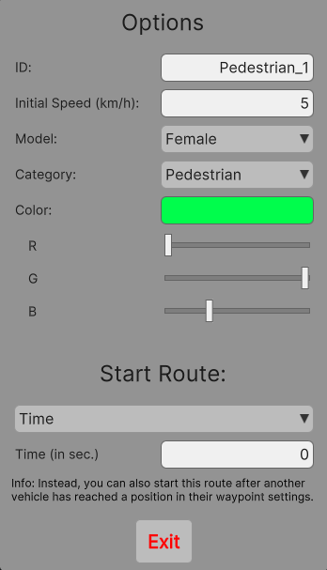 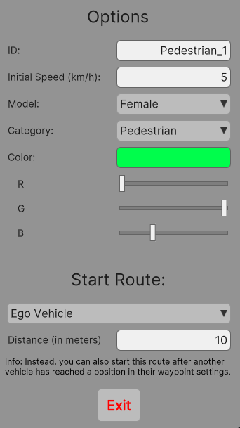  
Next, the events are specified. The pedestrian will start moving when the Ego Vehicle is close. This can be done in the **Entity Settings**. The Start Route option will be changed to **Ego** **Vehicle**. And the distance is set to **10** meters.

Ein Bild, das Diagramm enthält.
Next, we create an additional **waypoint** on the Simulation Car’s path. We do this by clicking on the pink vehicle and then clicking somewhere on the pink path. Then, we open the **Waypoint Settings** of this waypoint.

Ein Bild, das Text enthält.
Ein Bild, das Text enthält.
In the Waypoint Settings we select a **StopAction** in the dropdown. We change the Stop Duration to 5 seconds.

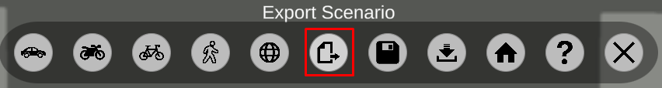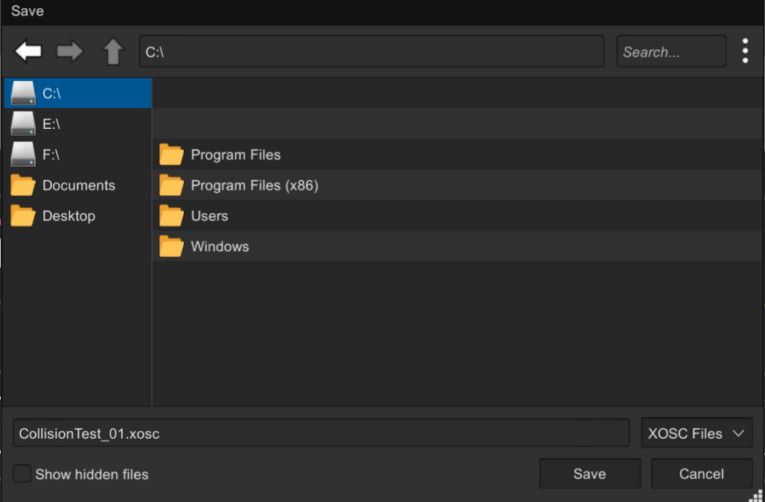  
In the last step we **export** the scenario. We click the button **Export Scenario**.   
This opens a file explorer. We call the scenario CollisionTest_01.xosc and click **Save** in the file explorer.